Name : | Ms.Neerja Doshi
UID | 2021300029
Div | SE CE DIV A – BATCH B

Experiment No. 6: ( Graph Algorithm - Single source shortest path algorithm..Dijkstra Algorithms

AIM : | ( Graph Algorithm - Single source shortest path algorithm..Dijkstra Algorithms
THEORY : | The Single-Source Shortest Path (SSSP) problem consists of finding the shortest paths between a given  - vertex v and all other vertices in the graph  - Bellman Ford algorithm works by overestimating the length of the path from the starting vertex to all other vertices.  - Then it iteratively relaxes those estimates by finding new paths that are shorter than the previously overestimated paths.  - Dijkstra algorithm is a single-source shortest path algorithm. Here, single-source means that only one source is given, and we have to find the shortest path from the source to all the nodes.  - ALGORITHM :  - Bellman–Ford :  - function bellmanFordAlgorithm(G, s) //G is the graph and s is the source vertex  - for each vertex V in G  - dist[V] <- infinite // dist is distance  - prev[V] <- NULL // prev is previous  - dist[s] <- 0  - for each vertex V in G  - for each edge (u,v) in G  - temporaryDist <- dist[u] + edgeweight(u, v)  - if temporaryDist < dist[v]  - dist[v] <- temporaryDist  - prev[v] <- u  - for each edge (U,V) in G  - If dist[U] + edgeweight(U, V) < dist[V}  - Error: Negative Cycle Exists  - return dist[], previ[]  - Dijkstra Algorithms :  - Mark the source node with a current distance of 0 and the rest with infinity.  - Set the non-visited node with the smallest current distance as the current node.  - For each neighbor, N of the current node adds the current distance of the adjacent node with the weight of the edge connecting 0->1. If it is smaller than the current distance of Node, set it as the new current distance of N.  - Mark the current node 1 as visited.  - Go to step 2 if there are any nodes are unvisited.  - Time Complexity :  - Bellman–Ford  - O(V * E)  - Dijkstra Algorithms  - O((V+E)LogV)
CODE : | #include <limits.h>  #include <stdbool.h>  #include <stdio.h>  // Number of vertices in the graph  #define V 9  // A utility function to find the vertex with minimum  // distance value, from the set of vertices not yet included  // in shortest path tree  int minDistance(int dist[], bool sptSet[])  {  // Initialize min value  int min = INT_MAX, min_index;  for (int v = 0; v < V; v++)  if (sptSet[v] == false && dist[v] <= min)  min = dist[v], min_index = v;  return min_index;  }  // A utility function to print the constructed distance  // array  void printSolution(int dist[])  {  printf("Vertex \t\t Distance from Source\n");  for (int i = 0; i < V; i++)  printf("%d \t\t\t\t %d\n", i, dist[i]);  }  // Function that implements Dijkstra's single source  // shortest path algorithm for a graph represented using  // adjacency matrix representation  void dijkstra(int graph[V][V], int src)  {  int dist[V]; // The output array. dist[i] will hold the  // shortest  // distance from src to i  bool sptSet[V]; // sptSet[i] will be true if vertex i is  // included in shortest  // path tree or shortest distance from src to i is  // finalized  // Initialize all distances as INFINITE and stpSet[] as  // false  for (int i = 0; i < V; i++)  dist[i] = INT_MAX, sptSet[i] = false;  // Distance of source vertex from itself is always 0  dist[src] = 0;  // Find shortest path for all vertices  for (int count = 0; count < V - 1; count++) {  // Pick the minimum distance vertex from the set of  // vertices not yet processed. u is always equal to  // src in the first iteration.  int u = minDistance(dist, sptSet);  // Mark the picked vertex as processed  sptSet[u] = true;  // Update dist value of the adjacent vertices of the  // picked vertex.  for (int v = 0; v < V; v++)  // Update dist[v] only if is not in sptSet,  // there is an edge from u to v, and total  // weight of path from src to v through u is  // smaller than current value of dist[v]  if (!sptSet[v] && graph[u][v]  && dist[u] != INT_MAX  && dist[u] + graph[u][v] < dist[v])  dist[v] = dist[u] + graph[u][v];  }  // print the constructed distance array  printSolution(dist);  }  // driver's code  int main()  {  /* Let us create the example graph discussed above */  int graph[V][V] = { { 0, 4, 0, 0, 0, 0, 0, 8, 0 },  { 4, 0, 8, 0, 0, 0, 0, 11, 0 },  { 0, 8, 0, 7, 0, 4, 0, 0, 2 },  { 0, 0, 7, 0, 9, 14, 0, 0, 0 },  { 0, 0, 0, 9, 0, 10, 0, 0, 0 },  { 0, 0, 4, 14, 10, 0, 2, 0, 0 },  { 0, 0, 0, 0, 0, 2, 0, 1, 6 },  { 8, 11, 0, 0, 0, 0, 1, 0, 7 },  { 0, 0, 2, 0, 0, 0, 6, 7, 0 } };  // Function call  dijkstra(graph, 0);  return 0;  }
OUTPUT : | 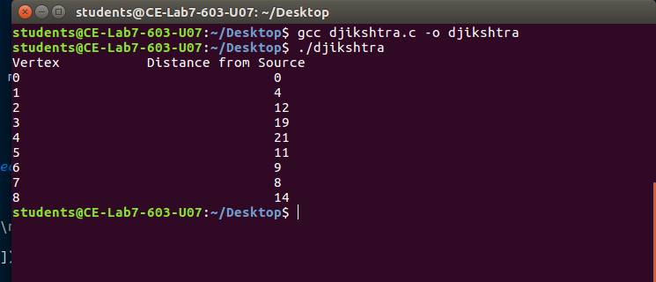
CONCLUSION : | By performing the above experiment , i have successfully understood to perform

